**LAWYERS**

|  |  |  |
| --- | --- | --- |
| FACULTY NAME | SIR Sadam Hussain | |
| BATCH | 2112d | |
| GROUP | Lawyers | |
| SERIAL NO: | ENROLLMENT NO | STUDENT NAME |
|  | 1335 | Hussain khozema |
|  | 1335 | Kabir ahmed |
|  | 1335280 | INSIYA YOUSUF |
|  | 1335 | Umehani halai |

**ACKNOWLEDGMENT**

*We would like to thank our mentor “Sir Sadam Hussain Who helped a lot in finalizing our project within the limited time frame and valuable counseling.*

*We would also like to thank the e-project team at Aptech Head office, who allowed us to do this interesting and wonderful project about Lawyers.*

*The following are the benefits of this project:*

*Re-enforcement of skills happens in the experimental learning process.*

*A mentor, ensuring that we do not get drifted, constantly guides us.*

*It gives us a lot of confidence to face an interview and to work on a project like this. We can explain virtually everything on the subject we have learned.*

***WEBSITE DETAILS***

|  |  |
| --- | --- |
| Name | LAWYERS |
| Theme color |  |
| Pages |  |
| Font Family |  |
| Font color |  |
| Languages | CSS, JavaScript, PHP, Blade, SCSS, Shell |
| Follow us | Facebook, Instagram, YouTube, Gmail |
| Gmail Name | lawyers@gmail.com |

*DESCRIPTIONS*

This website helps users easily hire lawyers whereas search engine helps them search for lawyers by their names and specialty. The website provides you with separate dashboards for super admins and lawyers.

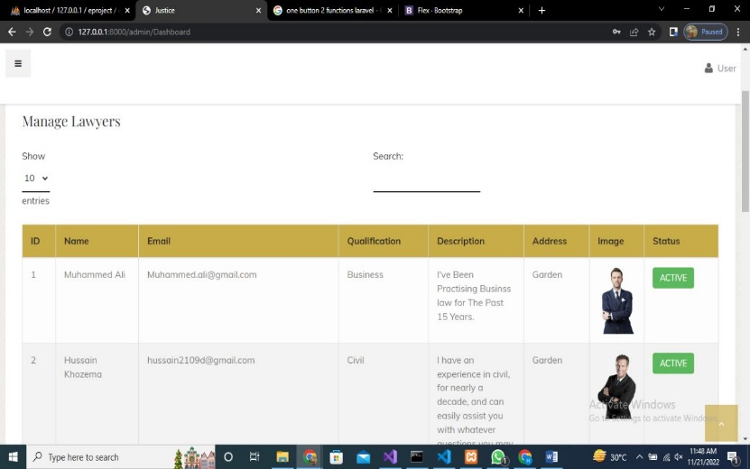

The Super admin dashboard has all the controls. A lawyer cannot activate themselves without the permission of the super admin.

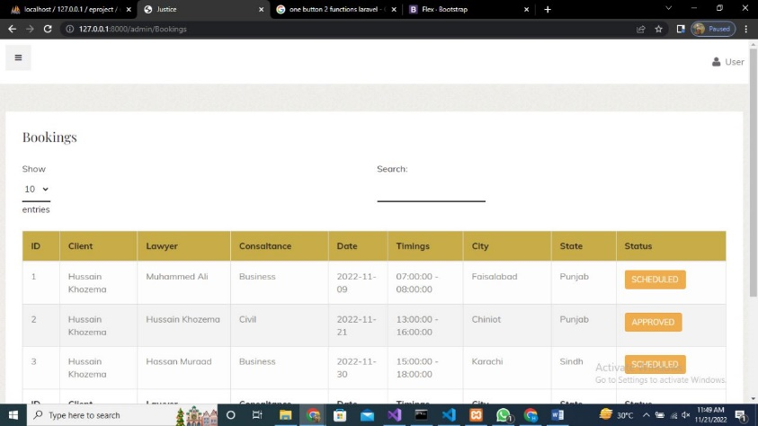

Super admins have all control over lawyers and their clients and can look over their bookings as well.

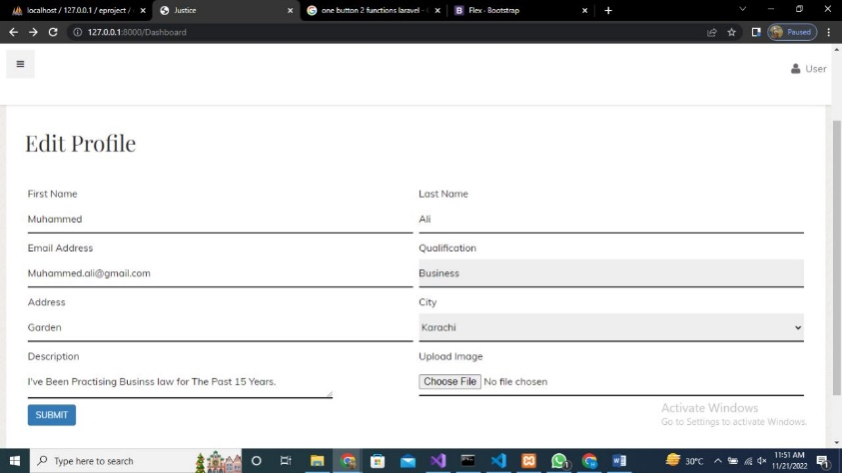

lawyers can edit their profiles and they can also see their bookings with their clients and contact them. lawyers can also schedule a meeting if the super admin approves their schedule.

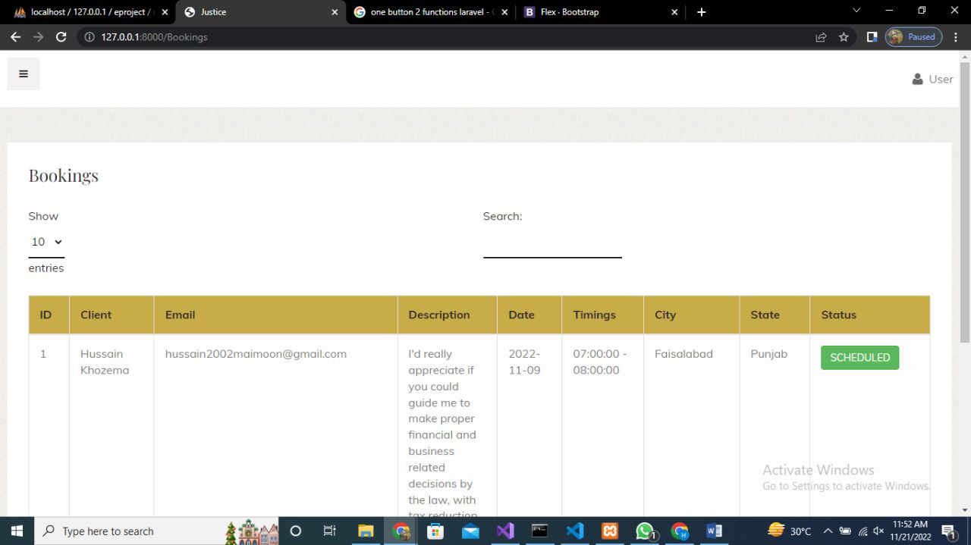

Super admins can go through all the bookings and has the authority to approve them according to time slots if there is no time slots available, they can disapprove the booking.

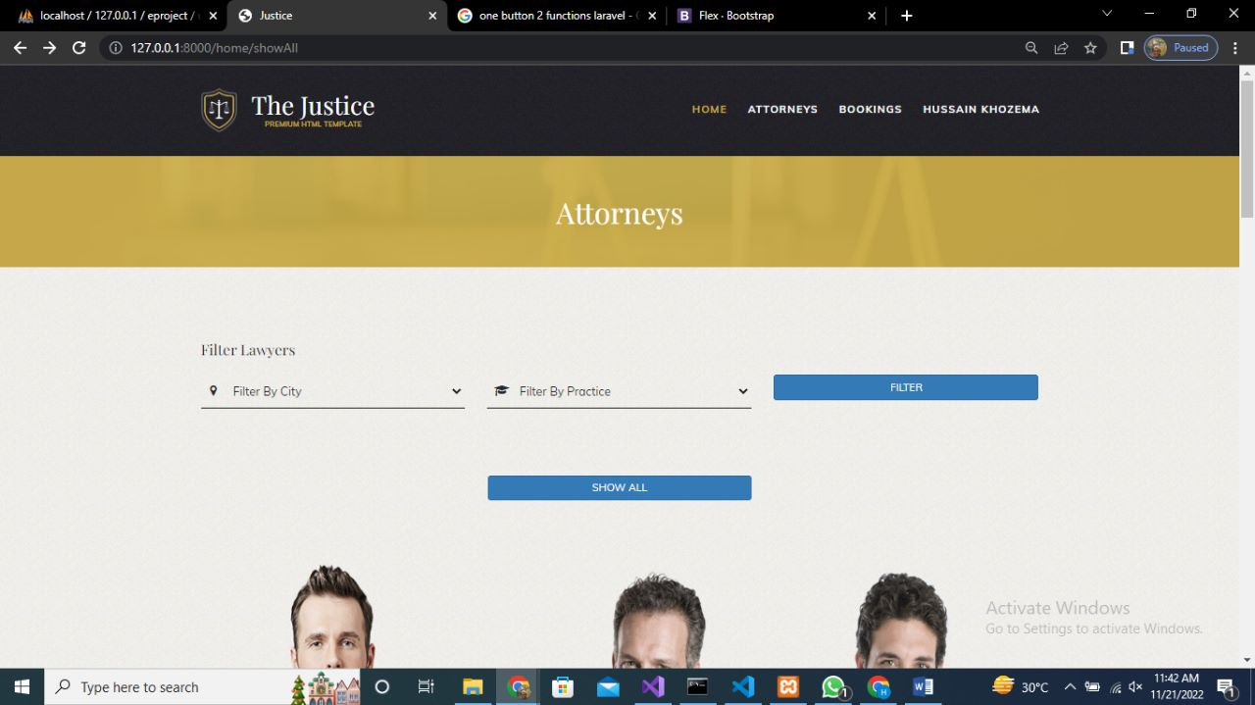

Registration page for lawyers where they can provide their main information like the city they live in, their address and most importantly their qualifications.

**CODE DETAILS**

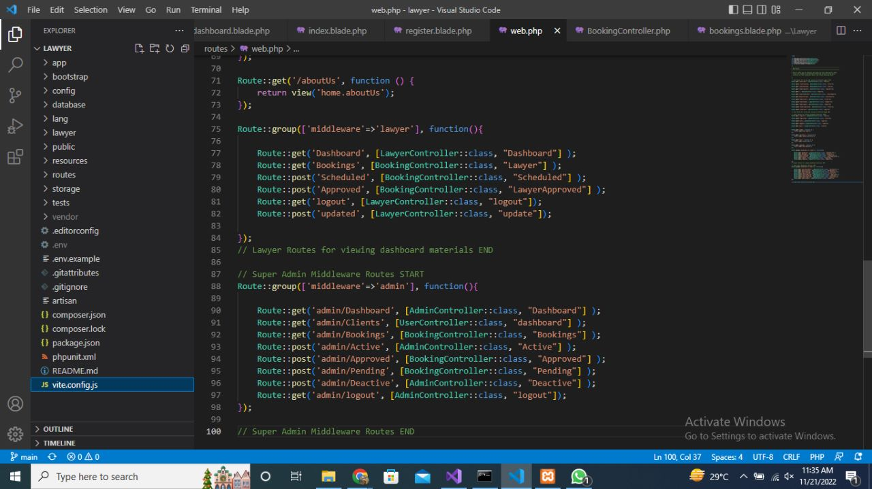

There's a function where you can search for a specific city of your desire and you can also search for the qualification of the lawyers as per your needs. We have shown the status if it’s active or inactive.

Lawyers can email the Clients for their meetings. And if for some reason the lawyer is not available he can inform the client of that as well.

**TASK SHEET**

|  |  |  |  |  |  |  |
| --- | --- | --- | --- | --- | --- | --- |
| Project Ref. No:  Ep/Advertisement  Portal  Management system | | PROJECT  TITLE | Date Of Preparation Of  Activity Plan | | | |
| No. | Task | L  A  W  Y  E  R  S | Actual  Start Date | Actual  Days | Team-Mate  Name | Status |
| 01. | WEBSITE | 2  2  -  O  C  T  O  B  E  R  -  2  0  2  2 | 2  2  -  N  O  V  E  M  B  E  R  -  2  0  2  2 | HUSSAIN KHOZEMA |  |
| 02. | DOCUMENTATION | KABIR AHMED |  |
| 03. | PRESENTATION | INSIYA  YOUSUF |  |
|  |  | UMEHANI HALAI |  |
|  |  |

END